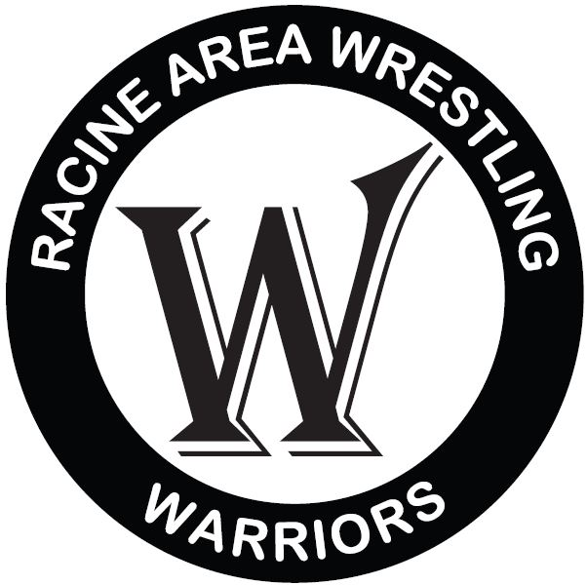**Racine Area Wrestling Code of Conduct**

The Racine Area Wrestling Club membership, board members and coaches are very proud of this organization, its wrestlers, and their accomplishments.How we conduct ourselves on and off the mat reflects on the participant, our Club, and the community of Racine. We always want to have the respect and status as one of the best clubs in the state.

**Parent Pledge**

As a R.A.W. Club parent, I acknowledge that I’m a role model and remember that athletics are experiences for kids that provide them positive traits to guide them through life.

* I will provide positive behavior, support, and encouragement, especially at “matside.”
* I will show respect for all other wrestlers, coaches, referees and spectators
* I understand what I say and what I do reflects directly on my wrestler, the club, and me.

As a R.A.W. Club parent, I hereby accept the responsibility of being a positive role model.

**Wrestlers Pledge**

As a R.A.W. Club wrestler, I acknowledge that I represent the Racine Area Wrestling Club and the local community. I understand that wrestling and other athletic activities teach me sportsmanship, self-discipline, and confidence;and traits that will last me a lifetime.

* I will show respect for all other wrestlers, coaches, referees and spectators
* I will participate by the rules of the sport and exhibit good sportsmanship at all times
* I will always strive to perform at my best.

As a R.A.W. Club wrestler, I hereby accept the responsibility of being a model of good sportsmanship.

I will not play on or use the gym equipment, if I break this rule I acknowledge I will be responsible for the repair or replacement.

**Disciplinary Action**

I realize and understand that if I violate this Pledge or Policy I will be subject to disciplinary action at the board of director’s discretion.

I have read and accept this Code of Conduct. I recognize that this Code of Conduct does not establish a complete set of rules for appropriate behavior, or provide the total spectrum of consequences for violation of these rules.